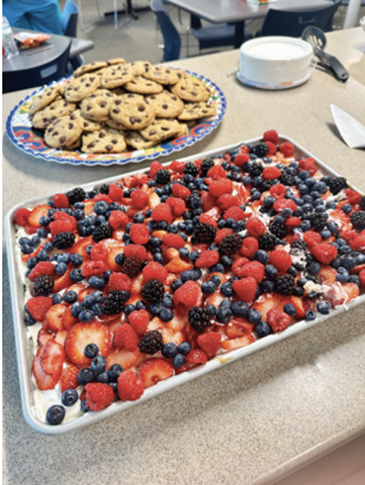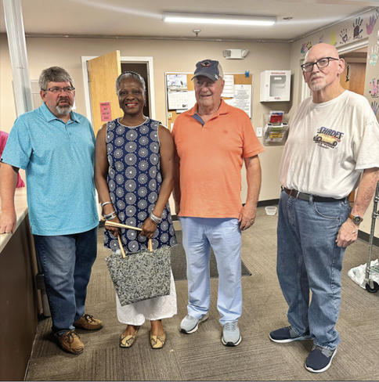

Women’s Extension- Residents of The Women’s Extension were treated to a fried chicken dinner accompanied by sides of mac & cheese and mashed potatoes, prepared and served by the Rotary Club of Marietta. We had 5 Rotarians volunteer on a sweltering, humid July 24, 2025 evening to help prep and serve the meal.
Homemade Tres Leches cake topped with fresh strawberries, blueberries, raspberries, and blackberries, along with homemade chocolate chip cookies, were the desserts for the evening.

