Back-to-school Teacher Bags- During the month of August, supplies and cash donations were collected to support Hickory Hills Elementary School. On September 3, 2025, 35 club members assembled 50 packets of school supplies for teachers. Each bag contained hand sanitizer, Clorox wipes, tissues, band-aids, Emergen-C, and mouthwash- items specifically requested by the school. The completed bags were given to Hailey Howdyshell, Teacher of the Year, to distribute throughout the school. Mrs. Howdyshell was also presented with a check from the Rotary Club of Marietta to congratulate her on her outstanding work.
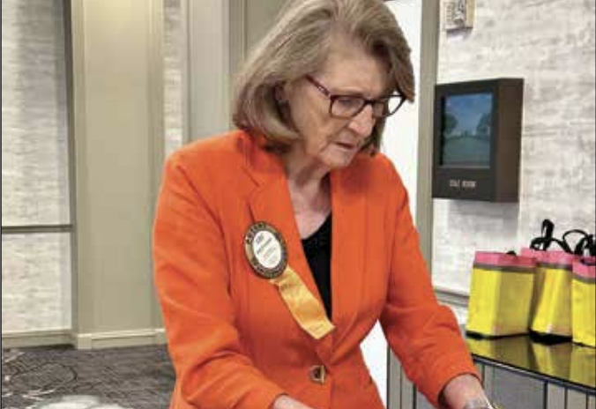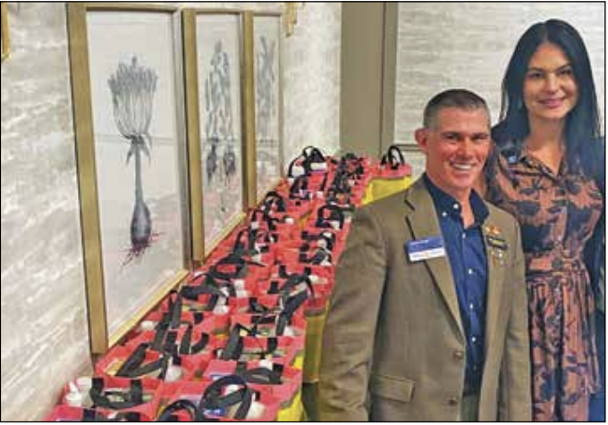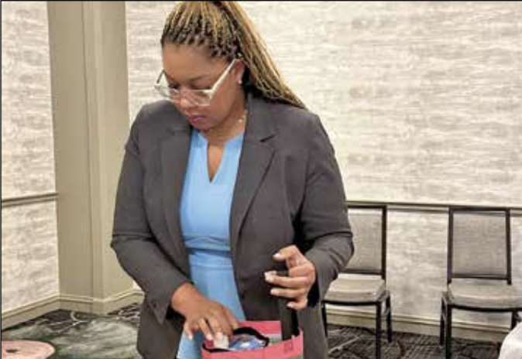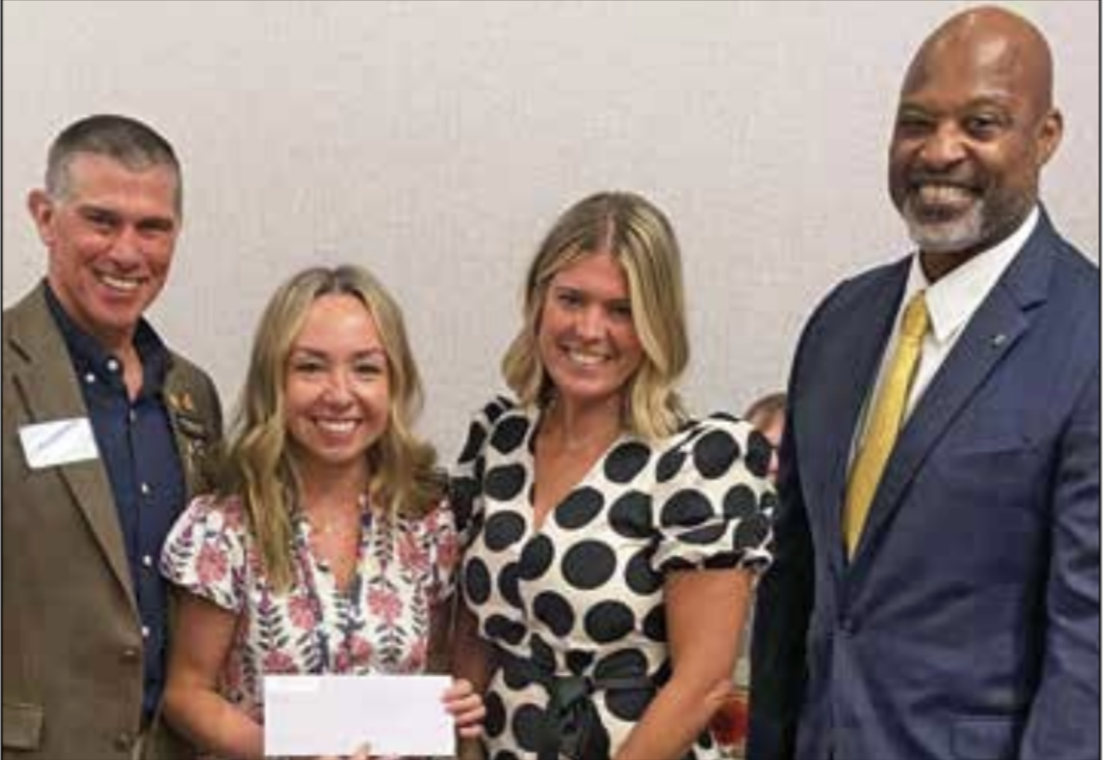
G

